JPDE2: Adagio of Darkness

GAME DESIGN DOCUMENT

**Version Number:** 1.0

**Date:** 06/06/2025

**Team Members:** Meinos Kaen, Skolaztika, Beardman...[TBA]

# What is JPDE2: Adagio of Darkness?

JPDE2: Adagio of Darkness is a Dungeon Crawler RPG with Dating Sim mechanics, taking place in an Alternate Universe version of RWBY's world of Remnant, three years after the events of JPDE: Sonata of Fire.

The player progresses through the story by overcoming battle challenges and clearing story dungeons. To increase their battle potential the player needs to complete quests to raise his Hunter Level, craft new skills and items from loot and rewards, raise their affinity with other characters through special events, upgrade their Battle Suit's statistics with XP gained from battle.

What is JPDE2: Adagio of Darkness? 2

The World of Remnant, JPDE2 Style 5

The Story So Far... 5

The Major Players 6

The Duchy of Peak 6

The Republic of Atlas 7

The Federation of Vacuo 7

The Red Fang 8

Salem 8

The Creatures of Grimm 9

Geography of Remnant 11

The Kingdom of Vale 11

A - Capital Region 11

Vale City 11

Island of Patch 11

B - Polaris Region 12

Polaris City 12

C- Sirius Region 12

Harvest Cove 12

D - Antares Region 13

E - Crescentia 13

Native Grimm 13

The Republic of Atlas 14

The Federation of Vacuo 15

A – State of Oasis 15

B – State of Silver Scales 15

C – State of Red Cliffs 16

Fortress of Red Cliffs 16

Native Grimm 16

The Empire of Mistral 17

The Island Nation of Menagerie 18

A – Capital Region 18

B – Menagerian Outback 18

C – Menagerian Jungle 19

Native Grimm 19

Quest System and Hunter Levels 20

Hunter Levels and Missions 20

Designing a Hunter Mission 20

Basic Information 20

Description 21

Example of Quest Info and Description 21

Gameplay Requirements of a Quest 22

Designing an Investigation Quest 22

Examples of Investigation Quest Flavor Texts 22

Designing a Dungeon Crawling Quest 25

Examples of Dungeon Crawling Setup 26

Tips when Designing a Hunter Mission Quest 28

# The World of Remnant, JPDE2 Style

Before JPDE, there was RWBY and its world, Remnant. Birthed by the mind of Monty Oum and refined by others at Rooster Teeth over 9 Volumes, JPDE1 tried to stick to the canon as much as possible as far as Volumes 1 through 3 were concerned.

That went straight out the window with JPDE2, which takes place after *three years* after the events of JPDE1. The Canon has been changed, characters have evolved and transformed, the world map itself has been modified and borders between nations have shifted.

**If you want to contribute to JPDE2, you must have played JPDE1**. Once you've done that, you're cleared to go. Otherwise, you won't understand most of the plot threads and events that are contained in this Game Design Document.

**You must also play the regular story updates of JPDE2, otherwise this document will contain spoilers for you**.

## The Story So Far...

JPDE1 spins out from the events of RWBY Volume 2. David di Kabegis is *born* out of an event caused by the machinations of Weser van Goethe, with the aim of resurrecting the Broken God Agni. Shortly after his birth, he meets Penny Polendina and eventually is put on a team with 'Orphans' Jacqueline "Jack" B. Ivory and Evelyn Damerot.

Despite their best efforts and that of their allies, Team JPDE is unable to prevent the resurrection of the Fire God who, despite only having recovered one out of four pieces of his essence, proves a formidable opponent. Similarly, they are unable to prevent the Fall of Beacon and in the events David loses his life, only brought back by the sacrifice of an ally. They do succeed, though, in bringing back Penny Polendina from the brink and in destroying the first ever recorded *Ancestral Grimm*...

Three years later, Remnant is a changed and divided place. In the relatively quiet years, the actors who brought about the Fall of Beacon have been silent as the consequences of their actions played out across the two major continents. But they are now starting to move again...

## The Major Players

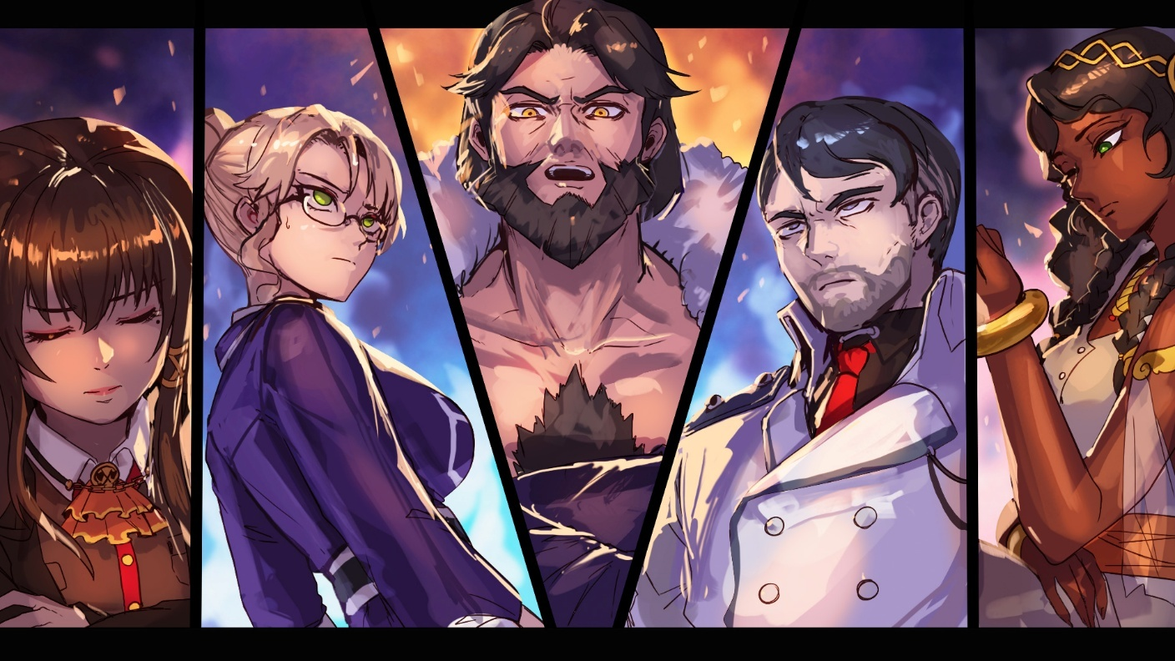

### The Duchy of Peak

The City of Peak was once a settlement built by a group of enterprising citizens of the Kingdom of Vale, on land donated to them by the Valesian Royal Family. It thrived as a mining city, biggest source of the once coveted Pyrobsidian metal, until the machination of Weser van Goethe, native to the city, brought upon its tragedy and for the territory to be declared No Man’s Land.

Following the Fall of Beacon and the extreme unpopularity of the Hunters from the Valesian chapter of the organization, Glynda Goodwitch led the students of Beacon and anyone else who would follow in an exodus to the empty city. Subsequently, the town started taking in the bulk of the refugees fleeing the Mistrali Civil War who had come to Vale. The city eventually started thriving, becoming a stable and interesting enough political actor to court a deal with the Federation of Vacuo and the Nation of Menagerie.

Following a heated security conference in Menagerie, the City State has managed to assert its independence, at least for a time. The issue has been pushed forward indefinitely until the end of the Mistral Civil War. Will it be enough time for the Duchy to build up enough political, economical and military strength for what comes afterwards…?

### The Republic of Atlas

Following the Fall of Beacon, a nation who had just started dealing with its systemic class and racial imbalances suddenly hit the reset button on many things. The images of the Atlesian Military being completely unable to stop the machinations of the White Fang and protect the civilian population stoked the worst instincts of the general population, and the Council of Four found themselves having -or relishing in the opportunity to- impose further and further restrictions on all aspects of life in a long-standing emergency situation.

In this chaos, Council Member and leader of the military General Ironwood rose to the newly created rank of President of the Republic. While it allowed him greater and swifter decisional power, it also made him the face of all the unpopular decisions the Council made. So good it was for certain members of the Council, that the role is soon to be made permanent…

Which is exactly what Ironwood was counting on. Once fully empowered, he plans to flip the balance of power on its head through political maneuvering and new elections, overturning in the interim many of the most draconian of decrees adopted by the Council, particularly the hated racially charged discriminatory laws targeting Fauni. Then, with his country united behind him, he plans to bring the full might of Atlas and his allies on the *true enemy…*

Many of his advisors warn that this plan will paint an enormous target on his back. Atlas, if apparently stable and safe, hangs that equilibrium on a knife’s edge…

### The Federation of Vacuo

The birthplace of Dorothea Grimm and, through her, of the modern conception of the Hunter, the Federation of Vacuo has changed immensely through the decades, particularly after the end of the Great War. While Vacuo was no stranger to skirmishes with its neighbor of Vale, the Great War was a conflict unlike any they had ever faced: their centuries of accumulated knowledge and experience in fighting Grimm were useless against an enemy with a human face and overwhelming technological advantage.

Only terrible loss of life and the sins of the last king of Vale brought them back from the brink. Following that, the once centralized nation changed to a federation of decentralized and functionally independent states. The academic caste of the Semer lost much of its favor to the Kozier warrior caste, and the rapidly rising Phitier caste of artisans and merchants. Their fleet of airships and ingenuity turned peace-time Vacuo into the premier mercantile power in Remnant.

In this comfort, though, the weaknesses of the federal system started to show up. The life of a citizen of Vacuo changes greatly depending on where they’re born, with no apparent standardization of basic services across the different states. Isis Ozma, Headmistress of Shade Academy, saw the need for a different Vacuo after the Fall of Beacon. Now successfully Elected Sovereign of the Federation, her policies focus on re-centralizing much of the power that had been left to the states and raising the Semer caste back to notoriety. Doing anything else, to her, would allow certain *zones of shadow* that had been left unattended for far too long continue to fester… And for what comes next, that just won’t do.

### The Red Fang

The First Generation of the White Fang was born out of the Remnant-wide movement for Faunus Rights. Their campaigning and peaceful protesting efforts brought upon many victories and change for the better, they seemed to eventually fall short in the face of the economic power of the Schnee Company. The tensions over a worker rights bill in Vale culminated in the bloody White Monday, where peaceful protesters turned to violence… And in doing so, managed to sink the bill once and for all.

This brought upon the Second Generation of the Fang, under the leadership of Sienna Khan. Now a hybrid organization, the White Fang would keep up the legitimate campaigning and influencing efforts while also developing armed paramilitary operations, bringing about change they saw otherwise impossible to be pushed through the system. Particularly when it came to the policies of the unrepentant Jacques Schnee.

Unfortunately for Sienna Khan, among the new blood she brought in one young and supremely talented man by the name of Adam Taurus would end up being fully extremized and would mastermind, in collaboration with the Valesian underworld and a not fully identified mysterious third party, the terrible events of the Breach of Vale and the Fall of Beacon, in quick succession.

Three years later, through a barely foiled assassination attempt, Adam Taurus’s take-over of the Fang is complete. Renamed the organization the Red Fang, all that’s left for him is to consolidate his power over the remaining regional leaders of the organization before continuing down the path that would bring about the glorious, pure future of his race…

### Salem

No one alive, except for one young girl growing up in the Duchy of Peak, has laid eyes on this mysterious figure. Information about her come from a number of sources, a lot of them not fully trusted and most not disclosed to the public. If one were, though, to put together the information available into one summary…

The entity known as Salem is the last surviving member of the first humans, a race known through legends of many populations as the Magic Users. What wiped them out is unclear, and so is the full past of Salem. What is know is that it left her *very* disillusioned with modern humans and with a pernicious hate for all Gods, up to and including the recovering Agni.

Her aims and plans are unclear, as her agents keep mostly to the secrecy of shadows, acting covertly instead of out in the open, influencing people, nations and -most dangerously- the Creatures of Grimm into doing their bidding. For what end-goal, it’s unknown, but what is certain is that they require the power of the Four Maidens of Legend… Three of which are already in her grasp.

Since the Fall of Beacon, nonetheless, Salem’s organization has been silent, her focus being on tracking down someone who had *seriously* wronged her. Now that this sinner’s trail has gone cold, though, her agents are refocusing on the original plan again…

### The Creatures of Grimm

The eternal and ancestral enemies of humanity. Seemingly with no end to their numbers and variety, born from human fears and single-mindedly devoted to the destruction of all humans on Remnant… For as long as humans have fought the creatures of Grimm, more recent have been the efforts to try and understand them and their workings, starting with the travels of Dorothea Grimm.

Advances in technology allowed more precise and deeper observation of the Grimm. Made of dark matter, they’re classified into different classes depending on their strength and age: normal-fare Grimm, Great -or Alpha- Grimm, and Gargantuan Grimm. The Fall of Beacon, though, has revealed a before unheard of class: the Primordial Grimm.

These Grimm, unlike all their peers, are incredibly powerful, stationary and do not obey their destructive instincts unless a huge concentration of human suffering is amassed over a short period of time, thus awakening them from their slumber. Their role is to repurpose Dark Matter into new Grimm, thus perpetuating their never-ending cycle of birth, violence and death.

This discovery, if it came at a great cost, tore open the veil of invincibility as it exposed the Grimm as a more traditional system than one would have thought. If all of the Primordial Grimm were to be found and destroyed, like the one dormant in the Kingdom of Vale, would Grimm stop being born? It is something to consider.

On the other hand, the Grimm have shown themselves to be nothing if not adaptable. How will the ecosystem react to their newfound vulnerability? How will the more independent and older Gargantuan Grimm…?

## Geography of Remnant

### The Kingdom of Vale

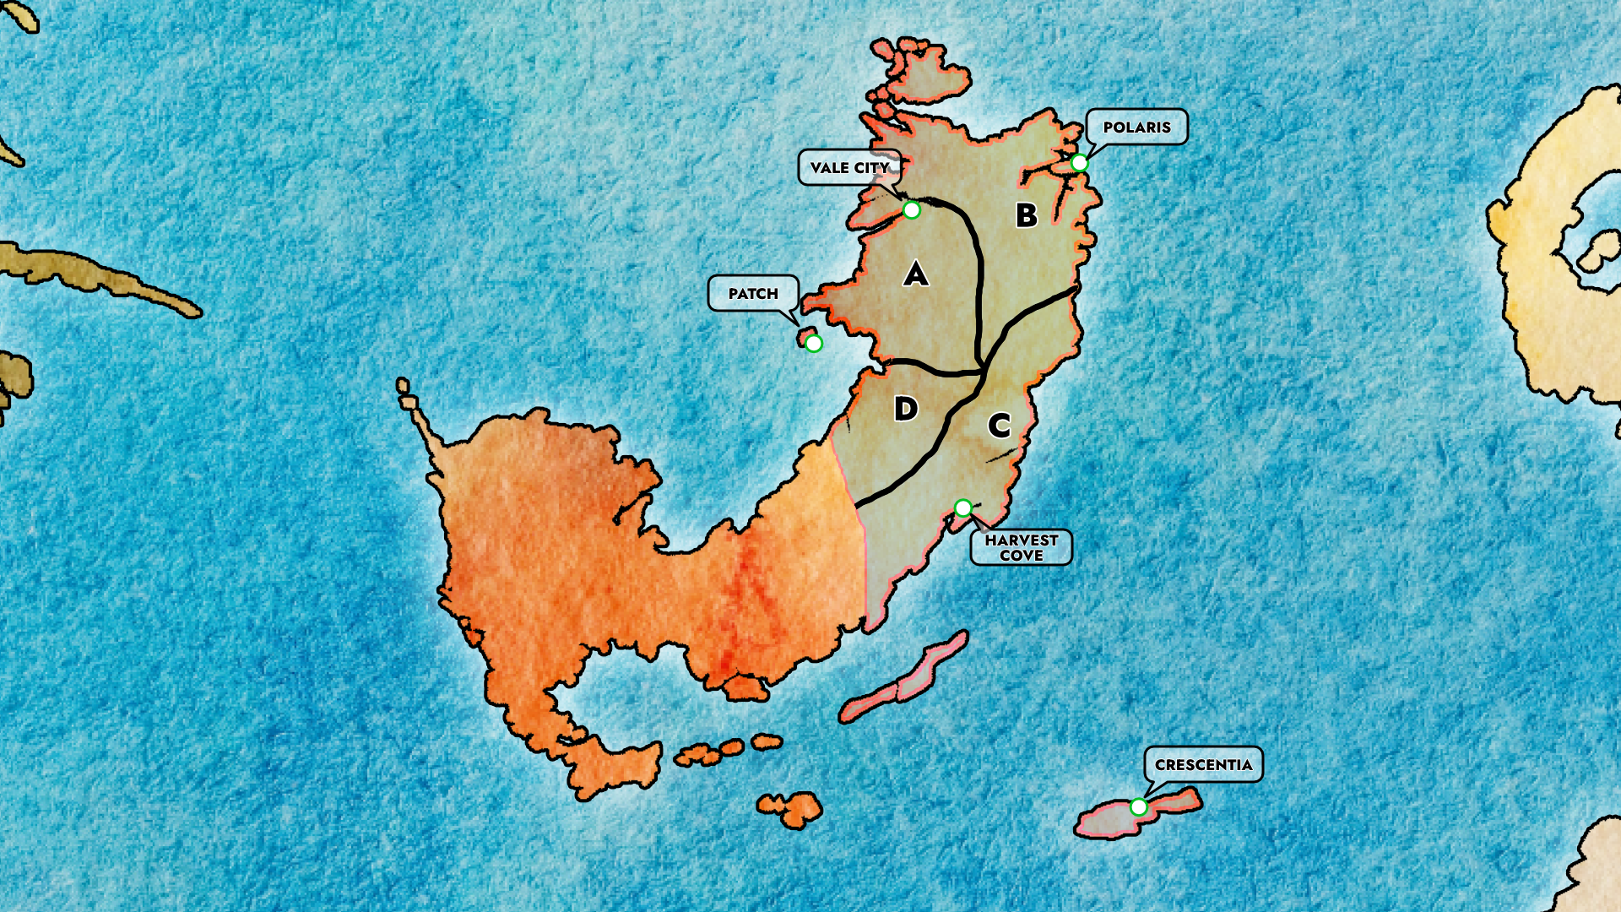

#### A - Capital Region

The richest and safest of the four administrative regions of the Kingdom of Vale, it is also the one where nature -and Grimm- have been tamed the most. Travel in the region is relatively safe, but that safety and infrastructure capillarity gets weaker the further south and east from the capital one gets… Source of most of the lumber of the kingdom, it is also its industrial heart.

##### Vale City

Capital of the Kingdom of Vale for centuries. Once the thriving cultural heart of Remnant, the Fall of Beacon has left it cowed, afraid and increasingly isolated from the rest of the Kingdom, as the new Atlesian-advised High Council has favored increased protection of the cities, leaving rural areas to fend for themselves or turn to a certain new breakaway city state for protection…

##### Island of Patch

Once a favored vacationing place for the royal family of Vale, it nowadays still maintains that attractiveness for city folks due to its temperate climate, relative absence of Grimm and beautiful beaches. It also houses the shipyards and headquarters of the Royal Northern Fleet of the Kingdom and Signal, a mixed civilian and hunter academy.

#### B - Polaris Region

Due to its favorable climate, Polaris is the breadbasket of the Kingdom of Vale, much of the continent itself and the Republic of Atlas. Not just that, Polaris is also renown worldwide for its wine and cheese culture, although many outside of the region know only the most priced varieties… Which suits the locals just fine, leaving the just as good but more reasonably priced varieties affordable for the internal market.

##### Polaris City

If Vale City is the ancient capital, to this day the administrative center of the Kingdom, Polaris is by far the richest and most prosperous of the regional capitals. In its ports, ships come and go to Atlas and Mistral, carrying goods and people… Although, in the case of Mistral, the influx of goods has been at least partly replaced with a steady trickle of war refugees, which the local authorities are more than happy to ship off to the Duchy of Peak.

#### C- Sirius Region

For as long as it’s been assimilated into the Kingdom of Vale, the Sirius region has been left in ‘salutary neglect’ from the central administration, which has allowed it to continue developing its unique character. Separated by the rest of the Kingdom by the Wyrm Mountain Range, which cuts in half the entirety of the Vacuovalesian Continent, the region has seen the passage of every single culture and foreign power under the sun. Vacuosi nomads, Atlesian explorers, Mistrali would-be conquerors and finally, were assimilated by the Norther Valesians.

With as much in common with their cousins in Southern Vacuo as the rest of the Kingdom of Vale, the variety of climates creates a region populated by a variety of people and local cultures. Unfortunately, the salutary neglect also left it to be the least safe and least developed region in the kingdom.

##### Harvest Cove

The regional capital of Sirius is built on a steep incline that from the coast reaches up to around 500 meters above sea levels. This, combined with the many fortifications built thanks to the abundant stone quarries present in the region, left the city unconquered until their capitulation to the unifying Kingdom of Vale’s superior navy. It also leaves a particularly gorgeous city filled with monuments and old churches to the Old Faith of the twin gods which, nonetheless, do not reflect the state of the rest of the region.

#### D - Antares Region

Before the Great War, the region of Antares was at times an important trade route between Norther Vacuo and Northern Vale, and at times a buffer acquired by Vale to try and fight eventual skirmishes with Vacuo away from the capital region. Sparsely populated, save for a few mining towns close to the Wyrm Range in the east, its most notorious features are the scars left by the war as this region saw the last stand of the united front of Vacuo and Vale against Atlas and Mistral, with more people having lost their lives in Antares in those few weeks than in the rest of Remnant during the rest of the war. Its most famous landmark remains Vodrunum, the battlefield where the last King of Vale decided the war with what historians say was a single swing of his sword…

#### E - Crescentia

Smack down in the middle of the Inner Sea, the island of Crescentia has seen wild swings in popularity and importance over the course of its history. Started as a Valesian commercial outpost on the way to southern Mistral, it acquired immense strategic importance during the Great War. With the war over, and the advent of airships, its commercial and strategic importance waned, and with it its population…

It's recently picked up in notoriety, though, thanks to a freshly brewing culinary culture brought on by a particularly talented cook at the Benbow: inn famous for hosting Queen Ambrosia Valesianis on her many visits to the island. A practitioner of the Old Faith of the Twin Gods, she delighted in the piousness of its inhabitants and the ruins of what historians have deemed to be the oldest consecrated grounds to the Twin Gods on Remnant: the Ruins of the First Church.

#### Native Grimm

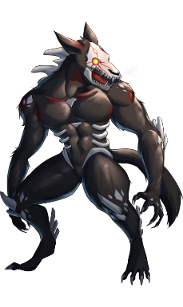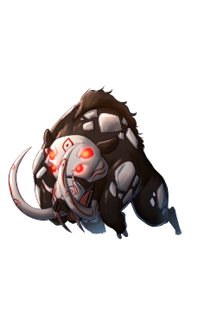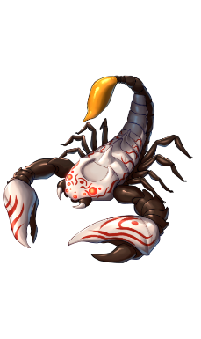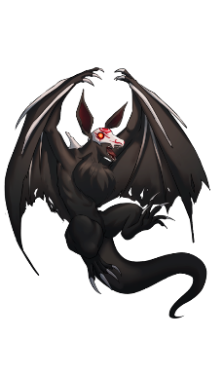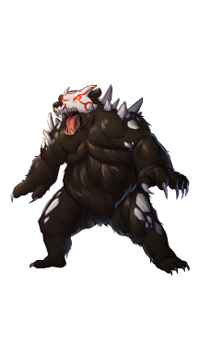

### The Republic of Atlas

TBA

### The Federation of Vacuo

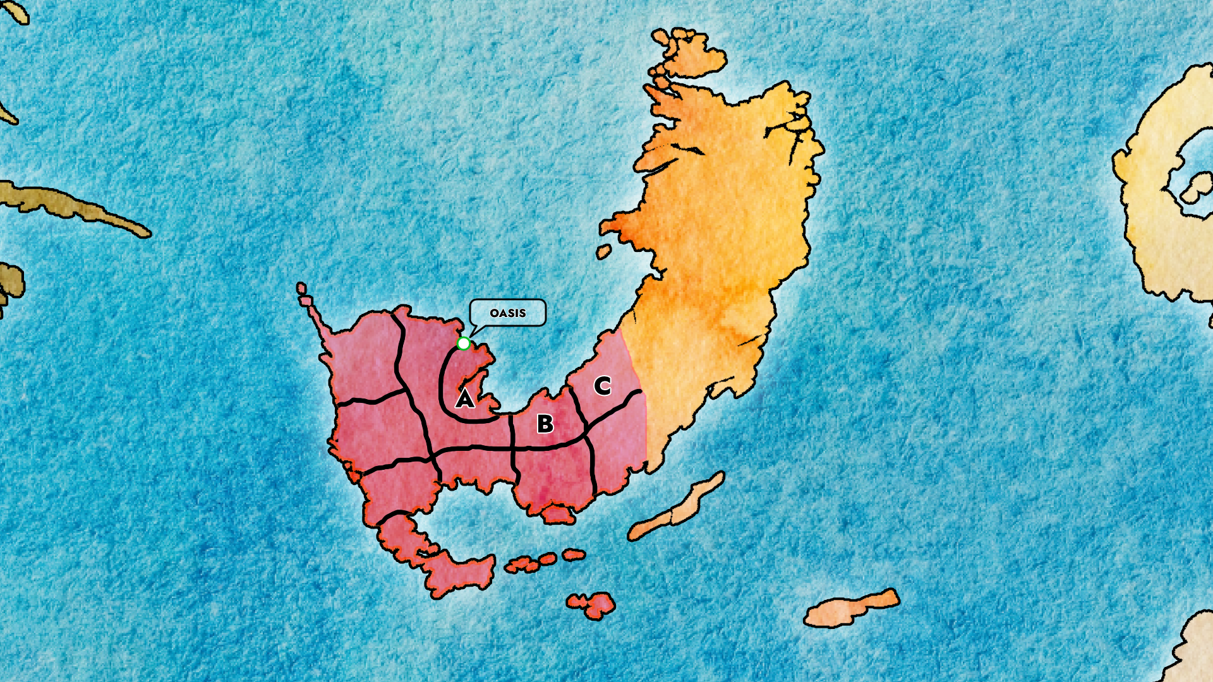

#### A – State of Oasis

The smallest of the states in the Federation, it is also the most important one as it contains the capital of the entire Federation, from which the state takes its name: Oasis. The first permanent settlement in the history of a region populated by mostly nomadic tribes, Oasis started as a fishing village in what remains to this day one of the richest fishing areas in Remnant.

This newfound bounty of food eventually lead to more people coming to settle in the city, which expanded and with it its control over the surrounding territories, thanks to the establishment of a warrior caste whose entire reason of existence was slaying Grimm, and eventually a Scholar caste who dedicated their lives to studying and understanding grimm.

Oasis is nowadays a city of marble libraries, obelisks, spices, spectacular terraces overseeing the gulf, and intrigue as the newly elected Sovereign seeks to re-centralize the Federation…

#### B – State of Silver Scales

So named due to the Moonfish, the prized catch of the gulf which remains a staple of the region to this day, the State of Silver Scales is where most of the fisheries and fish-related industries of Vacuo reside. As the first fully developed state of the federation on the old road from Vale, it’s been getting increased foot-traffic from the central administration ever since the effects of the Fall of Beacon put the spotlight back on the neighbour state to the east…

#### C – State of Red Cliffs

The Vacuosi twin of Vale’s Antares administrative region, the State of Red Cliffs takes its name from the rock formations that litter its cold desert climate, and served as both trade artery and buffer region between the two at times partner at times enemy states.

Following the development of Airships and the Great War which firmly made the two neighbors allies, the region fell from grace, with most of its settlements situated on the coastline and all its once prized fortifications abandoned, for the joy of certain terrorist elements…

Following the Fall of Beacon, the administrative capitulation of Vale’s high council to Atlas and the election of the new Sovereign, Red Cliffs has suddenly returned to being of much interest to the Federal Authority.

##### Fortress of Red Cliffs

An ancient fortress, built on top and out of one of the many formations of red rock that populate the Vacuo-Valesian cold desert. It was abandoned once its water source ran out but recent events, recounted to the Federal Authority by their newest ally the Duchy of Peak, revealed that the water source didn’t dry out but was simply deviated by a nest of Grimm. Considering its position, if the Grimm were to be stamped out, it could yet again become a strategically important location for Vacuo…

#### Native Grimm

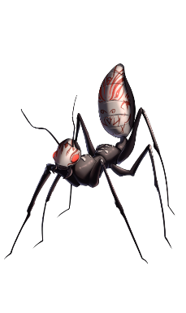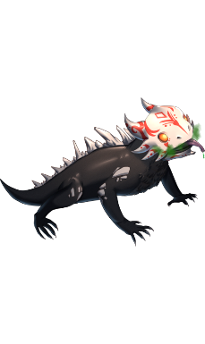

### The Empire of Mistral

TBA

### The Island Nation of Menagerie

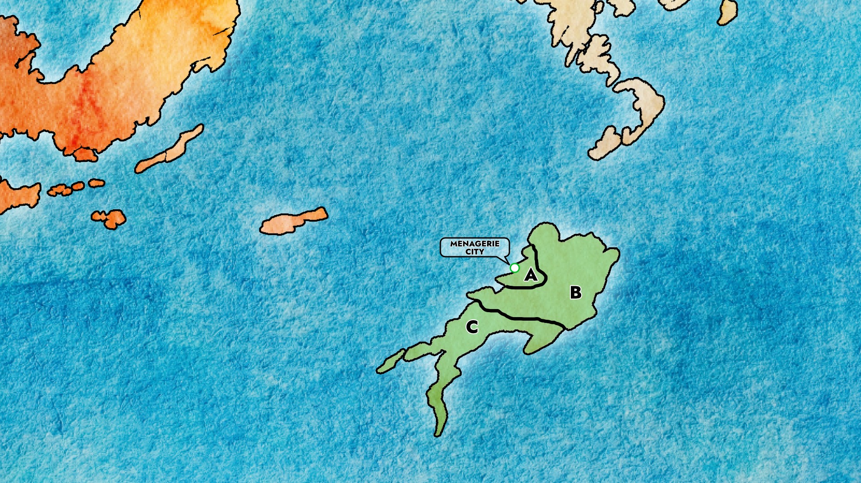

#### A – Capital Region

The biggest and only settlement on the island, Menagerie is also the youngest city on known Remnant. Born out of both spite and resilience when the Fauni people, following the Great War, accepted the gracious gift of an untamed island filled with dangerous environments, animals and Grimm to make a ‘home’ out of.

Nonetheless, those first settlers thrived and turned an once shabby settlement into the jewel of the Inner Sea, perfect tourist trap for Atlesians who come spend absurd amounts of money for the privilege…

The influx of Fauni refugees from Mistral and the general climate of distrust towards them after the Fall of Beacon, though, has caused the population of the city to rapidly balloon and force the leaders of the nation, the Belladonnas, to seriously consider expansion into the rest of the island…

#### B – Menagerian Outback

Collective name given to the vast regions that extend through most of central and northern Menagerie. Extremely variegated in climate zones, going from hot steppes to arid deserts to monsoon forests, it is full of unique rock formations, animals and Grimm that can’t be found anywhere else on Remnant. Most of it remains untamed and unexplored to this day but that may soon change, thanks to a recently struck deal between the Island Nation and the Duchy of Peak…

#### C – Menagerian Jungle

TBA

#### Native Grimm

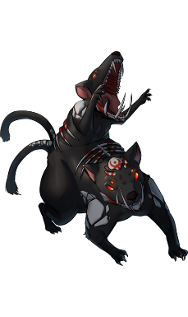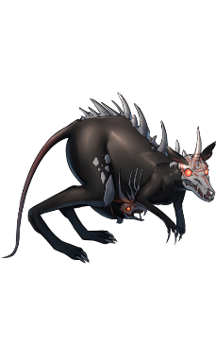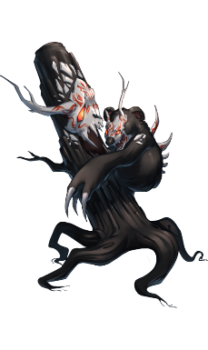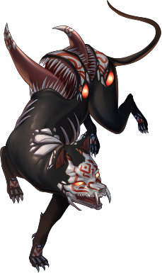

# Quest System and Hunter Levels

## Hunter Levels and Missions

In JPDE2: Adagio of Darkness, there's only two ways for the player to earn money: their Hunter stipend, received regularly, and by selling loot collected on missions. The Hunter stipend increases with their **Hunter Level**, and their Hunter Level increases by gaining **Hunter Merits** after successful missions.

In-between **Story Events**, the Player will have a certain number of **Free Roaming Days**, to use as they see fit. They can encounter available events with other characters, perform minigames or go on **Hunter Missions**.

**All Quest Files must be created in VSCode, and they must be .RPY files. This helps Coders then put quests in the game more easily.**

Designing a Hunter Mission

A Hunter Mission is JPDE2's version of a Side-Quest. A fully designed one needs the following components.

### Basic Information

These are the basic information of the Quest, which will be displayed when choosing it from the Map Screen.

**TITLE –** A Title for the Mission, hinting at the nature of the request. "Lost Pet", "Missing Spouse"... If the Quest is of a wittier nature, you can get more creative like "A Serious Case of the Apathies".

**CLIENT –** The Name and Title of the Quest Giver. "Jacob Rossi - Mayor", "Honey Levant – Baker", "Timothy Green – Tyke" are all valid examples.

**LOCATION –** The Location of the Quest Giver. This doesn't necessarily mean that the Quest will then be performed in the same location, it's just to group up all Quests in the same macro-areas.

**DAYS –** The amount of in-game time days required to complete the mission. The Player won't be able to undergo the mission if there's not enough days before the next story event.

**REWARD –** The amount of Hunter Merits the Player will receive upon completion. Sometimes, missions can also give bonus items and loot.

### Description

This should be a block of a text which contains details about the mission and describes its evolution, updating as the Quest is accepted, performed and finished. After completing a Hunter Mission, it will be moved to the 'Completed' tab of the Quests Menu, so it's important to keep that in mind if the ending of a Quest would cause the description to be changed in some way.

### Example of Quest Info and Description

**TITLE –** The Grimm Reaper

**CLIENT –** Glynda Goodwitch

**LOCATION –** Island Nation of Menagerie

**DAYS –** 2 Days

**REWARD –** 100 Hunter Merits

**DESCRIPTION**

**[QUEST START]** Maria Calavera, the Grimm Reaper. A Hunter of legendary skill, with the most recorded kills of Gargantuan Grimm in recorded history. A loner and wanderer, she has never formally joined any Hunter Organization, and rarely stays long enough in one place to be tracked down.

This is the kind of individual that Ruby Rose has chosen as her teacher, behind suggestion from her mother Summer Rose, and is the kind of individual which the Duchy of Peak would love to bring into the fold. As luck would have it, Sienna Khan possessed intelligence that places her on the Island Nation of Menagerie...

**[STEP 1]** After a brief roadblock in getting some information from a partly distrustful menagerian populace, [p_n] and his team manage to track down Ruby and Maria to the Menagerian outback. The reunion, with much potential for emotion, turned into a Penny-led farcical moment which left the veteran quite stunned.

**[STEP 2]** Maria has revealed herself to not be as resistant to the idea of joining the local hunters as one might have thought... But, unimpressed with the team's showing so far, lays down a challenge: impress her enough with their Skill and she will give the offer serious consideration... Much to Ruby's surprise.

**[QUEST COMPLETE]** After a day of 'testing' Maria Calavera had originally refused the offer of joining the Royal Hunters, while simultaneously graduating Ruby Rose as her apprentice. Overnight, her choice changed, probably due to a private conversation she had with her student...

## Gameplay Requirements of a Quest

A Quest is something that should involve player interaction of some kind. This can be either **Dungeon Crawling** or **Investigation**. When designing a Quest, the Writer should craft a setup that necessitates one, the other, or both in the case of more elaborate Quests.

### Designing an Investigation Quest

A Citizen of Vale has decided to hire a Hunter to retrieve a family heirloom from an abandoned house in the middle of the wilderness. The Writer decides that this Quest will just involve exploring the house, which means that reaching the location itself will be automatic.

Upon reaching the Location, an Investigation will start. Investigation is reminiscent of Point-and-Click adventure games, with the Player investigating objects until he either finds what he needs and/or deduces the information needed. The Writer needs to write down the various **Flavor Texts** which will be displayed when inspecting the environment. These will be thoughts from the PoV of the Main Character, dialogues between the Members of Team JPDE and/or their interactions with the environment.

#### Examples of Investigation Quest Flavor Texts

The Player reaches the abandoned house. The Investigation Screen pops up. Areas of the screen become interactive.

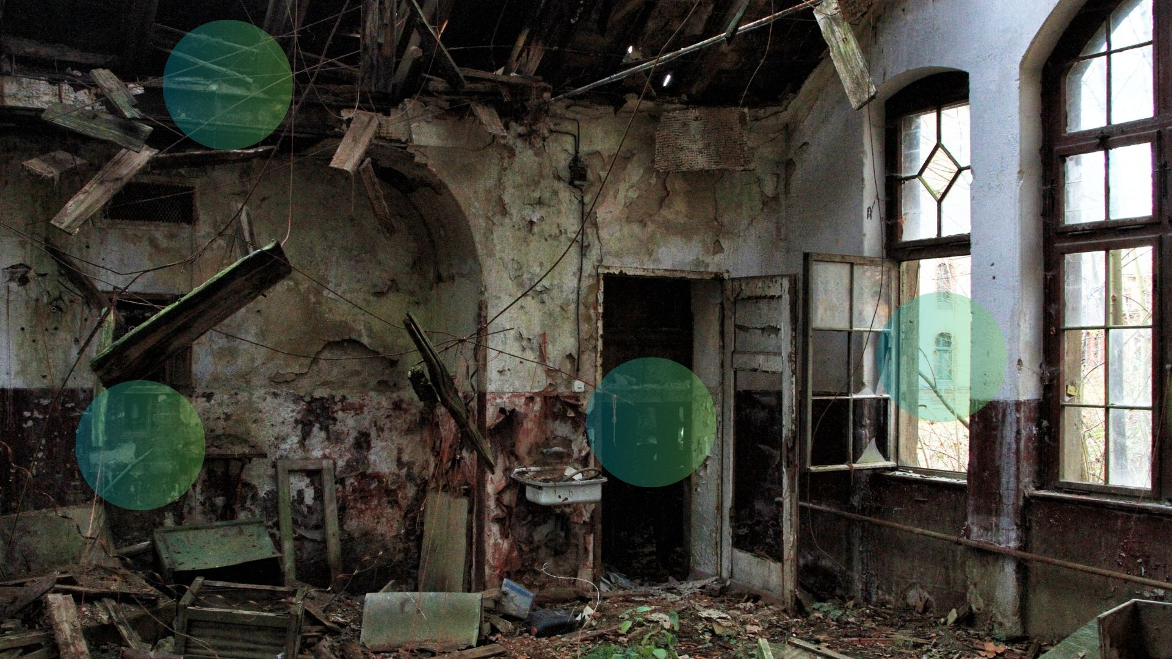

**[FLAVOR TEXT #1] WINDOW**

David (thought) Neutral: "(The window is shattered... And the scratch marks on the frame seem to indicate it was not because of age or weather.)"

Jack Surprise: "They did say the family left when they noticed a pack of Beowolves prowling increasingly closer."

Penny Surprise: "And no Hunter would come take care of them?"

Evelyn Sad: "Unfortunately, it would've been delaying the inevitable... Place this isolated, you can't defend it properly. Hunters can't be everywhere all the time."

David Frown: "They're lucky the Beowolves didn't just attack them outright..."

Penny Sad: "...still, how awful. Having to leave your home behind."

**[FLAVOR TEXT #2] ROOF**

Jack Surprise: "Huh, curious. You see that?"

Evelyn Surprise: "See what? The hole in the roof?"

Jack Smile: "Yes... And also the lack of tree branches. The structure is otherwise pretty solid, no?"

Jack Surprise: "Wonder how that happened. Termites, maybe?"

Evelyn Pain: "Oh ewewew I really hope not! Come on, let's find that ring and go!"

**[FLAVOR TEXT #3] COAT-HANGERS**

*If the coat-hangers haven't been inspected:*

Evelyn Sad: "Awwww, what a waste... Look at the stitching on this coat. Such a beautiful thing, ruined."

Evelyn Surprise: "Huh? Something fell out the pocket..."

Penny Surprise: "A keychain... One is clearly for the front door."

*If the safe has been inspected:*

David Smile: "What do you bet one of the others opens the safe?"

Jack Smile: "No bet. It's either that, or I freeze the metal off."

*If the safe has not been inspected:*

David Neutral: "Could be useful. If this ring was so precious, I bet they didn't just leave it out in the open."

Jack Neutral: "Now we just need to find a hole to use one in..."

*If the coat-hangers have been inspected:*

David (thought) Neutral: "(Nothing else of interest that I can see...)"

David Frown: "Evelyn, *no*."

Evelyn Sad: "Buuuuuut baaaaaaaaaabyyyyyyyyy~"

David Surprise: "You're an amazing tailor but not even you can do miracles."

Evelyn Frown: "Uuuuugh..."

**[FLAVOR TEXT #4] SAFE**

*If the coat-hangers haven't been inspected:*

David Surprise: "So, if I was a Betting Boy..."

Penny Smile: "A safe! Of course, if it was such a prized heirloom..."

Evelyn Surprise: "I see a keyhole behind this wooden panel... Guess that's how you open it?"

Jack Surprise: "Then we need to find the key. I doubt anything inside the safe would survive a Hunter-grad attempt and breaking into it."

*If the coat-hangers have been inspected:*

Jack Neutral: "The moment of truth. So, judging from the size of the hole..."

Jack Smile: "Yes! It opened!"

Penny Smile: "And look! Velvet cloth..."

Evelyn Smile: "And a pretty little ring in it. Nice bauble, not gonna lie."

David Neutral: "Not as nice as I thought it'd be... I guess the value is sentimental. Did the client mention why?"

Jack Sad: "Hmm, from what I gathered this was their grandmother's favourite ring and, well... You saw the tombstone outside?"

David Surprise: "...oh."

Penny Sad: "...guess they didn't have the means to relocate the body, or to pay someone to do it. Back then or today."

Evelyn Smile: "Wanna clean up the tombstone before we go?"

David Smile: "My sentiments exactly."

**[INVESTIGATION END]**

### Designing a Dungeon Crawling Quest

A Citizen of Vale has decided to hire a Hunter to retrieve a family heirloom from an abandoned house in the middle of the wilderness. The Writer decides that this Quest should feature team JPDE finding their way to the location through the wilderness and local enemies.

Upon accepting the mission, the Dungeon will start. The Writer needs to design a **Dungeon Table** which will be put inside of code to generate the Dungeon, and at least two **Dungeon Events** where Team JPDE will interact among themselves and/or with the environment.

#### Examples of Dungeon Crawling Setup

The Writer sets up a Dungeon Map in an Excel Sheet, which a Coder will then turn into code for the engine. [**EXCEL SHEET EXAMPLE**](https://1drv.ms/x/c/e74fd07d738cb475/EQBfys54CTlBtgYXQe_fPz0Bhv435N27mh-DDNW9dKZL-w?e=hPEPfw&nav=MTVfe0U5RTNCNDU3LTc3MEItNDhDQy1CMjUzLTI5QjM3MTczRTY4OH0)

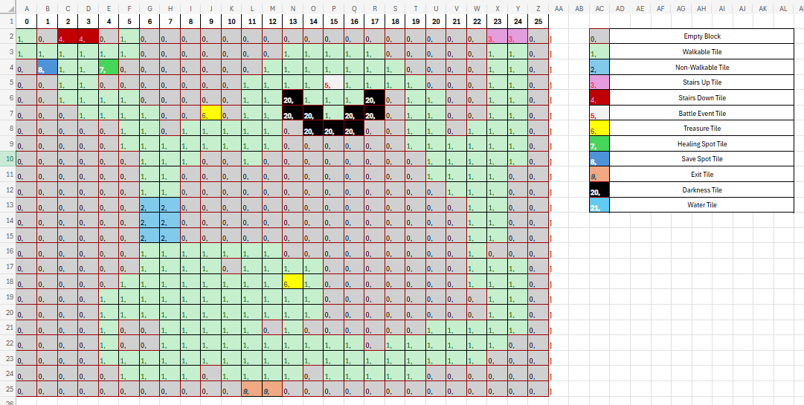

**[DUNGEON EVENT #1] ARRIVAL**

*The team disembarks from an Airship transport in a clearing a pace away from the last known location of the house.*

Jack Surprise: "Alright, team. Gather up! Penny, Evelyn, what do you have for me?"

Evelyn Frown: "Yeah, we're in Grimm Country alright. I can hear Beowolves, for sure, but also something else I'm unfamiliar with..."

Penny Frown: "I detect some kind of building north from here... The foliage was too thick to detect it from the airship."

David Neutral: "I'll take front and find us a path. Stick close and watch my back, I'll have an eye on my arm most of the way ahead."

Jack Smile: "Sounds like a plan, partner. Rendezvous with our transport is in T-Minus 90 minutes. Let's go!"

**[DUNGEON EVENT #2] DESTINATION**

Evelyn Surprise: "This must be it... Red rock and cobblestone, and a grave outside."

Jack Smile: "Good work, team. Carrots, you're with me. David, Penny, stay here and keep an eye out for more furballs, will you?"

David Surprise: "...the client mentioned that this ring was the last keepsake from their grandmother, correct?"

Penny Surprise: "Affirmative... And the name on that grave...?"

David Frown: "...removal of a corpse is a pretty expensive endeavor, yes?"

Penny Sad: "It is. Certainly not something a working class family can afford easily."

David Smile: "Wanna clean up the tombstone while we wait?"

Penny Smile: "I'll do it. Just watch my back."

**[DUNGEON END]**

## Tips when Designing a Hunter Mission Quest

1. **Keep difficulty and length in mind when deciding the Rewards –** The Reward in Hunter Merits should go from 10 to 100 depending on the difficulty and length of the Quest. On average, an Investigation Quest should result in less Merits than a Dungeon Crawling quest, unless the Investigation Quest becomes an intricate event in and of itself.  
   Items and Loot are extras and should be independent from the Hunter Merits. They can never replace Hunter Merits, all Missions must give at least 10 Hunter Merits.
2. **Team JPDE are the main available characters, others depend on Story Availability and Locations –** Team JPDE will have different allies to count on depending on the Story Progression and Locations the Quest will bring them to. Be sure to keep up to date with all JPDE2 main story updates to see who else of the main cast they can interact with on a Quest.
3. **Check already available Grimm, feel free to propose new ones –** ArsonicArtz can make new sprites for enemies very easily, so if you have a very good idea for a Grimm you want to use in the quest, either as fodder or boss battles, feel free to include them in the Quest. Be sure to check the list of currently available Grimm for see what's already available.
4. **Feel free to create named characters for the team to interact with –** Minor Characters won't have fully rendered sprites, and will be represented in dialogues by side-sprites, but other than that you have no restrictions, feel free to create any number of minor named characters you want.
5. **Pay attention to way main character names are defined, and sentences are written –** All sentences must be inbetween "", and all character names must be followed by an Emotional Indicator. This is important for people who need to turn dialogue into code and call graphical indicators, to make their jobs easier.
6. **Sky's the limit... –** Don't feel like you need to write epics, but also don't feel like you should always only write small vignettes. We're literally filling up the mostly empty world of Remnant with our own ideas, so write anything you want. It can be silly, it can be sad, it can be heartfelt, it can be smart. It can be anything...
7. **But keep the main story in mind –** With the caveat that you can't write anything that would go against the main story and the characterization of the characters therein. If in the main story Evelyn hates carrots, you can't write a story where she loves carrots. Although you can write one when she needs to fake it.